44.55: a)
b) Using (nonrelativistic) conservation of momentum and energy: 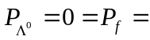
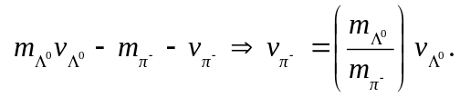
Also 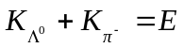 from part (a).
So 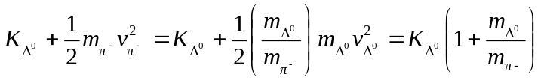
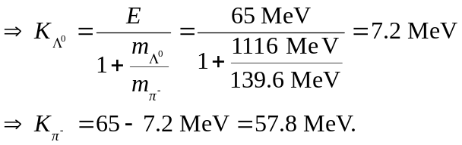
So the fractions of energy carried off by the particles are 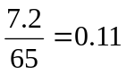 for the 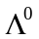 and
0.89 for the 